AMERICAN INTERNATIONAL UNIVERSITY-BANGLADESH

408/1, Kuratoli, Khilkhet, Dhaka 1229, Bangladesh

|  |  |  |
| --- | --- | --- |
| Assignment Title:  **Importance and application of computational chemistry** |  |  |
| Assignment No: **01** |  | **Date of Submission: 13/12/24** |
| Course Title: **Chemistry** |  |  |
| Course Code: **1101** |  | Section: **M** |
| Semester: **Fall 24-25** |  | Course Teacher: **Dr. Md. Abdullah Al Nahid** |

**Declaration and Statement of Authorship:**

1. I/we hold a copy of this Assignment/Case-Study, which can be produced if the original is lost/damaged.
2. This Assignment/Case-Study is my/our original work and no part of it has been copied from any other student’s work or

from any other source except where due acknowledgement is made.

1. No part of this Assignment/Case-Study has been written for me/us by any other person except where such collaboration has been authorized by the concerned teacher and is clearly acknowledged in the assignment.
2. I/we have not previously submitted or currently submitting this work for any other course/unit.
3. This work may be reproduced, communicated, compared and archived for the purpose of detecting plagiarism.
4. I/we give permission for a copy of my/our marked work to be retained by the Faculty for review and comparison, including review by external examiners.
5. I/we understand that Plagiarism is the presentation of the work, idea or creation of another person as though it is your own. It is a formofcheatingandisaveryseriousacademicoffencethatmayleadtoexpulsionfromtheUniversity. Plagiarized material can be drawn from, and presented in, written, graphic and visual form, including electronic data, and oral presentations. Plagiarism occurs when the origin of them arterial used is not appropriately cited.
6. I/we also understand that enabling plagiarism is the act of assisting or allowing another person to plagiarize or to copy my/our work.

*\* Student(s) must complete all details except the faculty use part.*

** Please submit all assignments to your course teacher or the office of the concerned teacher.

Group Name/No.: **Group D**

|  |  |  |  |  |
| --- | --- | --- | --- | --- |
| **No** | **Name** | **ID** | **Program** | **Signature** |
| 1 | CHINMOY GUHA | 22-48056-2 | CSE |  |
| 2 | SUVRA CHAKRABORTY | 22-48067-2 | CSE |  |
| 3 | ABDULLAH AL MAMUN | 22-48107-2 | CSE |  |
| 4 | FAHIMA TAJMOON TAFREE | 22-48109-2 | CSE |  |

|  |  |  |
| --- | --- | --- |
| ***Faculty use only*** | | |
| FACULTYCOMMENTS | **Marks Obtained** |  |
|  |
|  |
|  | **Total Marks** |  |
|  |
|  |

Assignment/Case-Study Cover; © AIUB-2020

**Importance and Application of Computational Chemistry:**

**Introduction:**

Computational chemistry is a field of chemistry that utilizes computer simulation to solve chemical problems. It uses mathematical algorithms, along with principles of theoretical chemistry, to allow researchers to model systems and predict properties. The importance of computational chemistry lies in the fact that it supports experimental chemistry by reducing the cost and risk, and even extends scientific inquiry into realms unreachable by experiment. This report discusses the significance of computational chemistry and its applications, showing how important this field has been in the transformation of various fields of science and technology.

**Insights Provided by Computational Chemistry:**

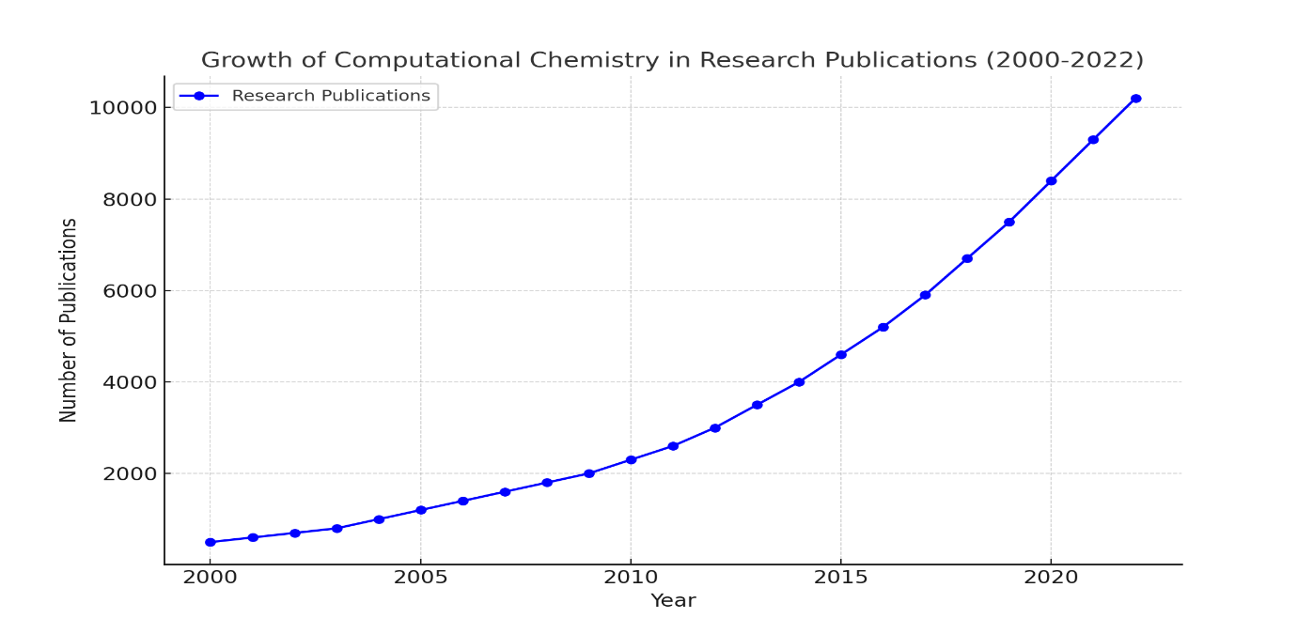Computational chemistry is an important part of modern research, as it can provide insight into the properties and interactions of molecules that are difficult or impossible to observe experimentally. For example, it helps in understanding reaction mechanisms, predicting molecular geometries, and calculating energy profiles. This allows researchers to formulate hypotheses and confirm experimental results more effectively. As a result, computational chemistry has become an integral part of academic and industrial laboratories around the world.

***Figure: Growth of Computational Chemistry***

**Applications in Drug Discovery:**

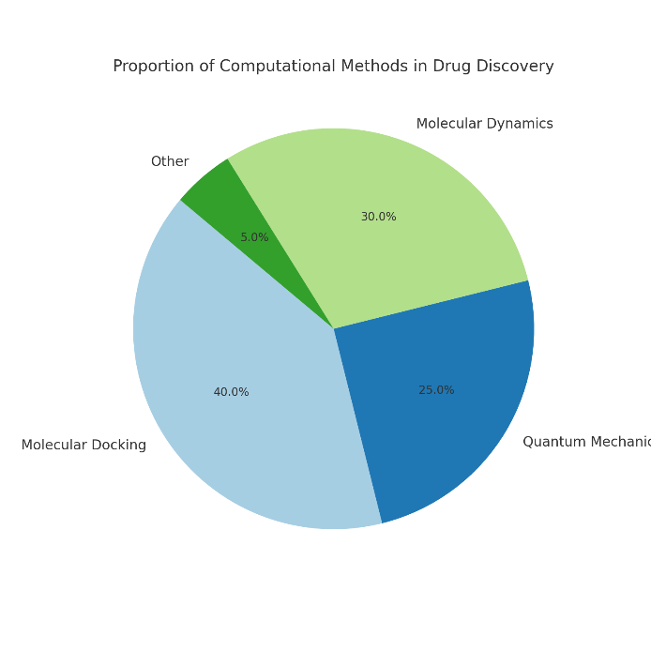The most active area of applications of computational chemistry is drug discovery. Computational techniques, such as molecular docking, quantum mechanics, and molecular dynamics simulations, provide a capability to identify prospective drug candidates and predict the nature of their interaction with biological targets. By streamlining the initial stages of drug design, computational tools reduce the need for extensive laboratory testing, saving time and resources. A very good example is the development of COVID-19 antiviral drugs, where computational chemistry played a key role in screening potential molecules.

***Figure: Proportion of Computational Methods in Drug Discovery***

**Contribution to Material Science:**

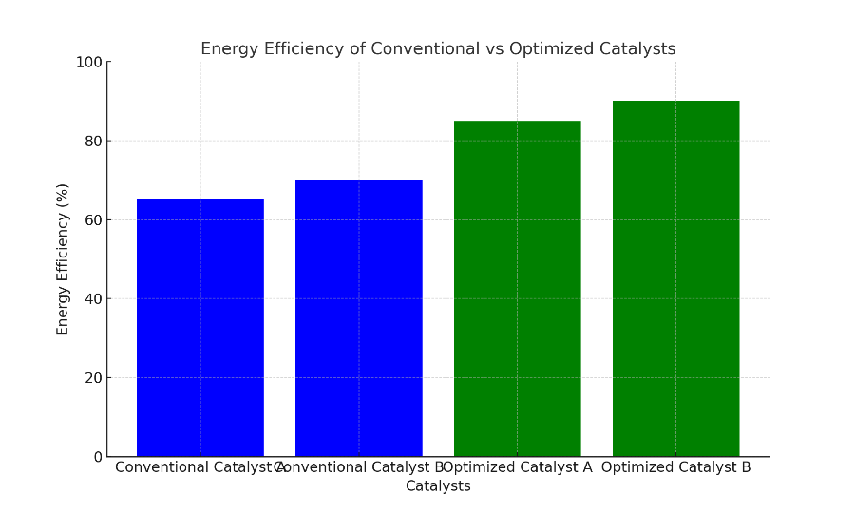Computational chemistry, therefore, helps in designing new material varieties with specific properties. Theoretical models are used by the researchers to predict the electronic, mechanical, and optical features of any material before preparing them. For example, it contributed to the discovery of high-performance polymers, energy-efficient catalysts, and new advanced battery materials. Since it can control material properties with accuracy, computational chemistry hastens innovation within the industries of aerospace, electronics, and renewable energy.

***Figure: Conventional vs Optimized Catalysts*.**

**Industrial Impact and Economic Benefits:**

Besides research, computational chemistry is a very valuable teaching aid. It allows students and young scientists to visualize the structure of molecules, simulate the course of reactions, and understand complicated concepts with the help of interactive software. In this way, educators introduce the next generation of chemists to solving real-world problems with state-of-the-art tools. Computational chemistry finds serious applications in industries such as pharmaceuticals, petrochemicals, and consumer goods. Companies achieve cost savings and faster time-to-market by optimizing processes and reducing experimental overhead. For example, chemical manufacturing processes are refined using computational models to attain improved product quality and lessened waste. The economic impact of these efficiencies underlines the strategic importance of computational chemistry within the global economy.

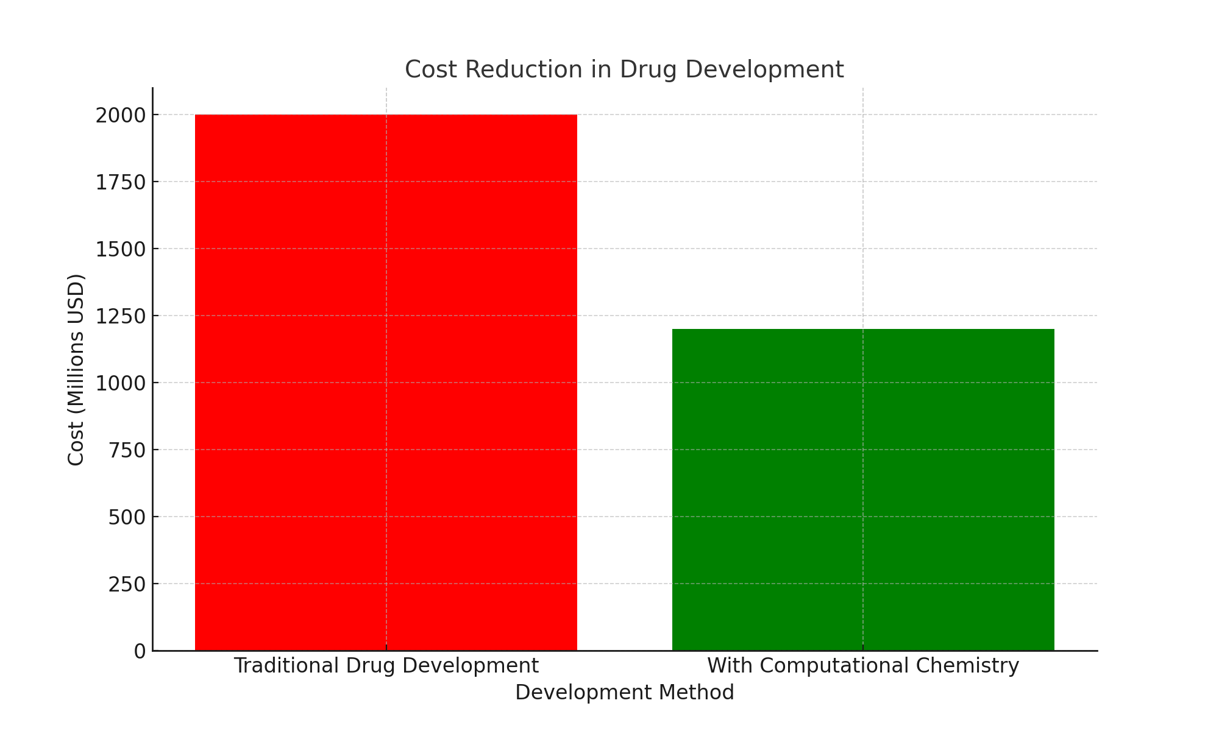

***Figure: Effect of Computational Chemistry on cost reduction***

**Challenges and Future Developments:**

Despite the many advantages, computational chemistry has its challenges, such as computational cost, accuracy limitations, and the need for big data. However, advances in AI and quantum computing are promising to overcome these barriers. Future developments may enable more accurate and large-scale simulations, further broadening the scope of computational chemistry. The integration of machine learning with computational tools is already demonstrating significant potential in areas such as property prediction and reaction optimization.

**Conclusion:**

Computational chemistry is at the avant-garde of scientific innovation, filling the gap between theory and experimentation. Applications are very varied, from drug discovery and material science to environmental sustainability and industrial processes. Though there are still challenges, the continuous evolution of computational technologies means that computational chemistry will continue to be a very important tool in solving global challenges and increasing human knowledge. As the field progresses, its impact will resonate across disciplines, shaping the future of science and technology.

**References:**

1. Jensen, F. (2017). *Introduction to Computational Chemistry* (3rd ed.). Wiley.

2. Leach, A. R. (2001). *Molecular Modelling: Principles and Applications* (2nd ed.). Prentice Hall.

3. Sliwoski, G., et al. (2014). "Computational methods in drug discovery." *Pharmacological Reviews, 66*(1), 334-395.

4. Cramer, C. J. (2013). *Essentials of Computational Chemistry: Theories and Models* (2nd ed.). Wiley.

5. Articles and research papers from journals such as *Journal of Computational Chemistry* and *Nature Chemistry*.